D.A.V.PUBLIC SCHOOL , NTPC , FARIDABAD
CIRCULAR ( For classes L.K.G to II )
DATE: 16.08.2020
Dear parents
Warm greetings !

As per the developmental research, each child passes through an identifiable
sequence of developmental changes i.e., physical, cognitive and emotional growth and change.So , it is very important for a child to follow good health , hygiene and safety rules for proper growth and development.
It is very important for parents and teachers to know about these changes in order to meet their needs appropriately.

It becomes essential for both parents and caregivers to educate children to become responsible fortheir own health and hygiene& growth and development.So,here are some tips that will benefit in the overall growth and development of the child-
- Washing hands before and after meals and maintaining cleanliness in the surroundings.
- Brushing teeth twice a day , cutting nails regularly, combing and cleaning hair properly.
- Hygienic nose blowing, coughing and sneezing , use of handkerchief and napkin.
- Safe food handling and eating , use of spoon for eating .
- Eating healthy food and avoiding junk food , have variety of fruits and vegetableseveryday for immunity boosting.
- Physical activities and exercise.
The assessment of growth of weight and height is also very crucial .During this COVID-19 lockdown, we request you all to keep on assessing the weight and height of your child . Kindly observe your child in the above mentioned points .
An observationperforma has been sent to you regarding the same. Kindly fill and share with the class teacher on the watsapp group.

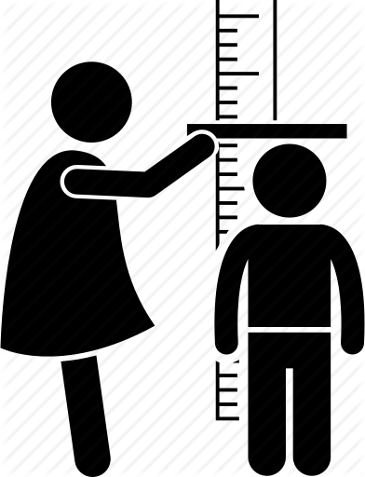

Regards

Mrs.Nishi Arora
( Coordinator )

